3 WAY GARDEN HOSE PIPE LOCK COUPLING SPLITTER MALE ADAPTOR CONNECTOR FAST JOINER
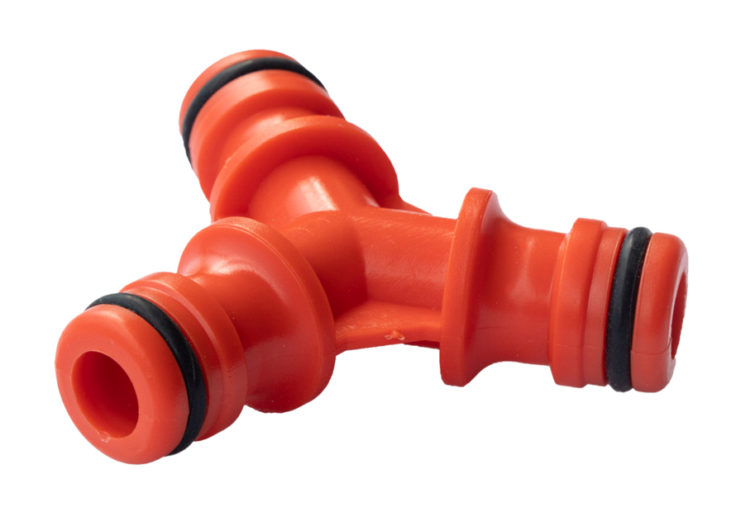
- For dividing or joining hose pipes using hozelock style quick connectors. This is the fast and simple way to split your hosepipe towards two devices.
With three universal male hose connector positions
ABS plastic, frost resistant and shatter proof
Ideal for all garden watering applications, car cleaning, etc.
- Part number: LMS131701
- Barcode number:8400800041074

